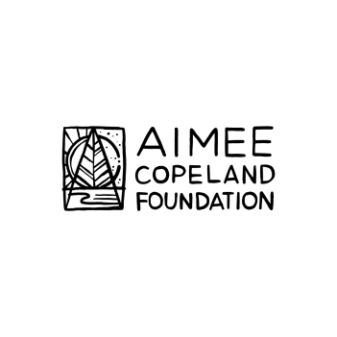
Aimee Copeland Foundation Presents

ECOTHERAPY FOR ALL ABILITIES

2018 Pilot Program

Program Description:
Participants will receive membership to Chattahoochee Nature Center for the duration of the program. Participants will meet every Friday in August and September for:
- Individual psychotherapy
- Group psychotherapy
- Group fitness
- Outdoor recreation

Eligibility Requirements:
- Must be between 18-40 years old and use a wheelchair for mobility

- Must have reliable transportation to and from Chattahoochee Nature Center:
9135 Willeo Rd, Roswell, GA 30075

- Must be available Fridays from 11 am-3 pm during the months of August & September, plus one hour weekly for individual therapy (to be scheduled on individual basis)

- Must be willing to work throughout the week on homework activities and exercises

- Must have caregiver to accompany if needed for toileting or other ADLs

- Must sign liability waiver with rules and regulations prior to participation

If you meet these requirements and are interested in being a participant in the Ecotherapy for All Abilities 2018 program, please complete and submit the following application by June 15, 2018.

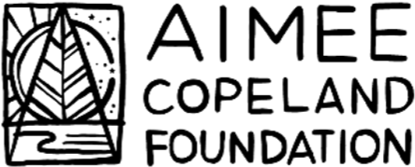

ECOTHERAPY FOR ALL ABILITIES

Application:
Please submit by email to advocateaimee@gmail.com no later than June 15, 2018.
Name:
Birth date:
Hobbies:
Skills:
Biggest strength:
Biggest weakness:
Biggest challenge in life currently:
In your own words, describe your disability:

What other issues are you struggling with?

Why should you be selected for the program?

What do you hope to get out of the program?

What else would you like to share?

Please attach a photo and send completed application to advocateaimee@gmail.com.
Selected participants will be notified by July 1, 2018.

