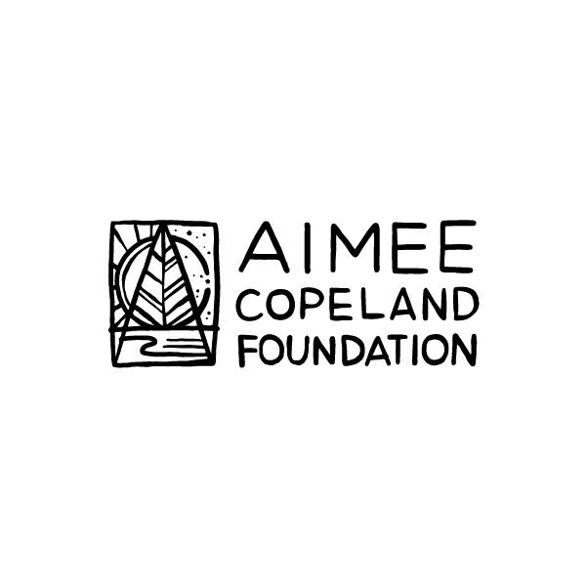
Presents
ECOTHERAPY FOR ALL ABILITIES

Program Description:
Participants will receive membership to Chattahoochee Nature Center. Participants will meet weekly for:
- Individual psychotherapy
- Group psychotherapy
- Group fitness
- Outdoor recreation

Requirements:
- Must be between 18-40 years old and have a disability
- Must be willing to travel to and from Chattahoochee Nature Center, 9135 Willeo Rd, Roswell, GA 30075. Accessible transportation assistance available.
- Must be available Fridays 11 am-3 pm, plus one hour weekly for individual therapy (to be scheduled on individual basis)
- Must be willing to work throughout the week on homework activities and exercises
- Must have caregiver to accompany if needed for ADLs, toileting, etc.
- Must sign liability waiver with rules and regulations prior to participation

ECOTHERAPY FOR ALL ABILITIES
Application:
Please submit by email to advocateaimee@gmail.com
Name:
Birth date:
Disability:
Hobbies:
Skills:
Biggest strength:
Biggest weakness:
Biggest challenge in life currently:
What other issues are you struggling with?

Why should you be selected for the program?

What do you hope to get out of the program?

What else would you like to share?

Please attach a photo and send to advocateaimee@gmail.com.

